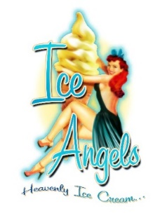
Price List for All Services (all quoted ex vat)

Delivery outside London charged at cost.

Nitrogen Ice Cream/Frozen Cocktail Service:
Bar hire, nitrogen and 2 serving staff = £900
Bar branding = £150
Ice creams/Frozen Cocktails @ £250/£350 per 100* = £
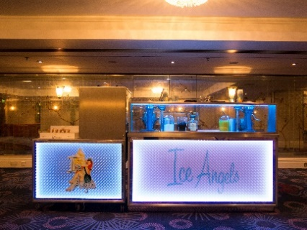
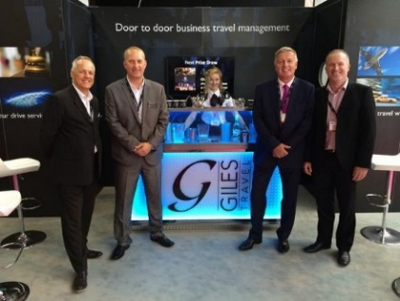
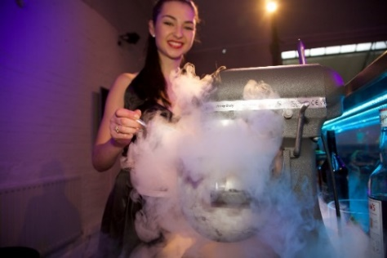

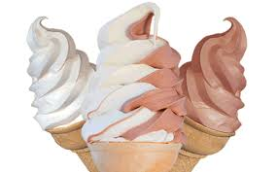
Soft Serve Ice Cream Service:
Bar hire and 1 serving staff = £750
Bar branding = £150
Ice creams with a selection of sauces and sprinkles @ £250 per 100* = £
Extra thick milkshakes in branded cups (made with ice cream) @ £220 per 100 = £

Other Ice Cream Services:

Delivery, outside London charged at cost = £
Staff, @ £175 per girl per day = £

Mini cones @ £75 per 100 = £
Filled tubs @ £200 per 100* = £
Branded tubs tbc
Tray branding @ £50 per tray = £
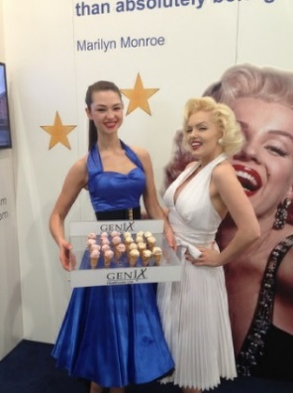
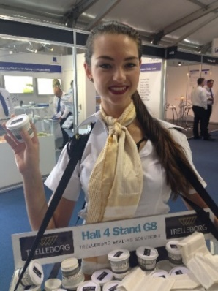
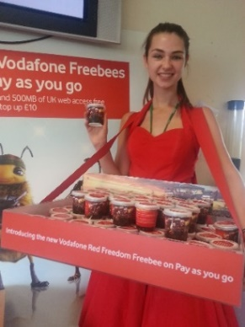

*Discounts available on nitrogen bar, ice cream bar and filled tubs for larger events.

Cake Pops:
Choc, vanilla or red velvet centre, 2 colours or sprinkles, cellophane wrapped and branded swing tag
@ £200 per 100 = £

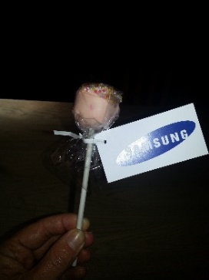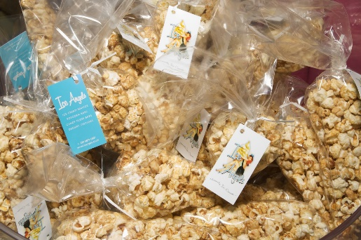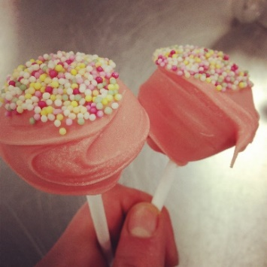

Popcorn:
Cellophane cones filled with sweet, salt or caramel popcorn, branded with swing tag
@ £100 per 100 = £
Served loose in branded boxes from popcorn bar (as below)
@ £170 per 100 (including boxes) = £

Cookies:
Individually wrapped choc chip cookies with branded sticker @ £170 per 100 = £

Macaroons:
2 mini macaroons (most colours available) in cellophane bag with branded sticker
@ £250 per 100 = £

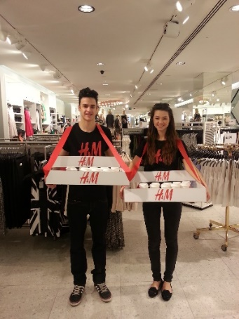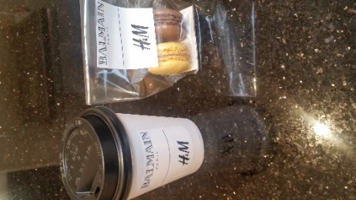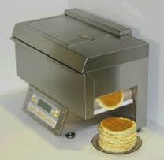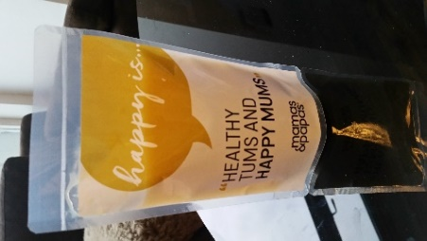

Hot Chocolate:
Perfect with branded macaroons for a winter treat!
Served in a branded cup/lid @ £150 per 100 = £

Pancakes:
Popcake pancake machine, makes delicious American style pancakes in seconds. Great with the soft serve bar!
Machine hire = £200
Unlimited pancakes and sauces @ £150 per 100 guests = £

Branded Drinks Pouches:
Healthy smoothies or naughty cocktails – the choice is yours!
From 50ml – 300ml = £POA

